NAME: SIVARANJANII.M EXP : 12
ROLL NO.:241901106

EXERCISE 12
LEARNING AND ASSIGNMENT OF IP ADDRESS MANUALLY TO COMPUTERS

AIM:
Learn to assign fixed IP addresses manually on a LAN, understand IP address basics, and test network connectivity.
ALGORITHM:
  - Open network adapter settings on the computer.
  - Choose Internet Protocol Version 4 (TCP/IPv4) properties.
  - Select “Use the following IP address.”
  - Enter a unique IP address, subnet mask, default gateway, and DNS servers.
  - Save settings.
  - Repeat on other computers with different IP’s in the same subnet.
  - Test connectivity by pinging between computers.

OUTPUT:

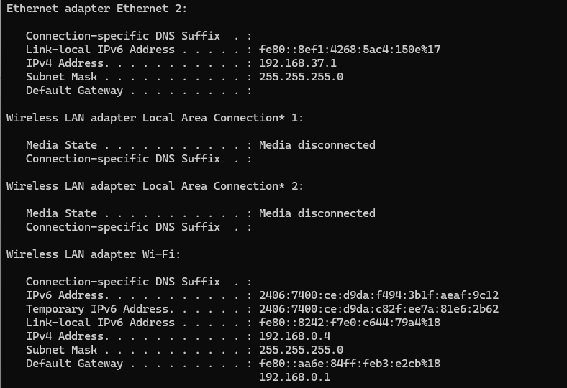

RESULT:
Manually assigned IP addresses allow reliable communication on the LAN. Successful connectivity tests (e.g., ping) confirm correct configuration. This method provides control over network addressing rather than dynamic assignment.

